Mpho Samuel Lukhele
Programming 2B
PROG6212
POE Part1

https://github.com/mpho04s/PROG-2B-POE-part-1.git
https://youtu.be/XGkOkXBRZZc?si=mkELfkBc6201wqYA

Section A
- ERD
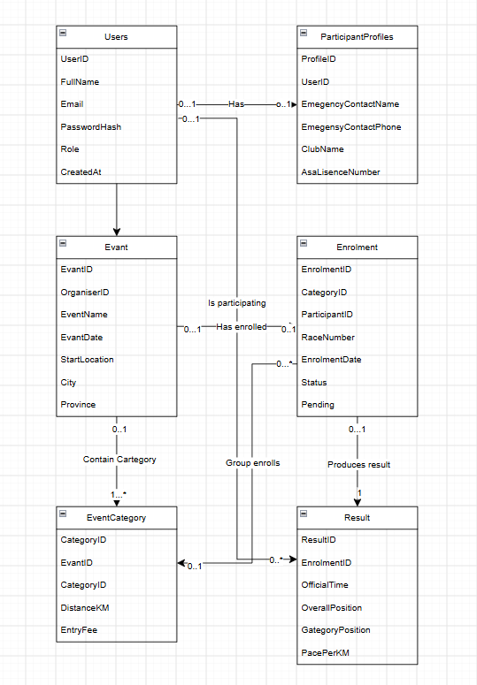

- RRCardinality & Relationships
User (Driver) to Car: 1 : N (One Driver can register multiple Cars; each Car belongs to one Driver).

Venue to Race: 1 : N (One Venue can host multiple Races; each Race takes place at one Venue).

Race to RaceEntry: 1 : N (One Race has many Race Entries; each Entry belongs to one Race).

User (Driver) to RaceEntry: 1 : N (One Driver can have multiple Race Entries across different events; each Entry is for one Driver).

Car to RaceEntry: 1 : N (One Car can be entered in multiple Races over time; each Entry specifies one Car).

RaceEntry to Result: 1 : 1 (Each Race Entry produces exactly one official Result row once completed).
Section b
HTTP Method | Route | Description | Role Required | Request Body | Expected Response
Post | /api/auth/register | Registers a new participant or organiser | Public |  | 201 created
Post | /api/auth/login | Authenticates user and return JWT | Public |  | 200 ok
Get | /api/user/profile | Retrieves profile and emergency info | Logged in | none | 200 ok
Put | /api/user/profile | Updates personal details and ASA licence | Logged in |  | 200 ok
Get | /api/events | Browses all upcoming road running & cycling events | Public | none | 200 ok
Get | /api/events/{id} | Gets event details along with weather/route info | Public |  | 201 created
Post | /api/events | Creates a new road running/cycling event | Organiser | none | 200 ok
Get | /api/categories | Lists race categories (e.g., 42km, 21km, 10km) | Public |  | 201 created
post | /api/categories | Adds distance categories to an event | Organiser | none | 200 ok
Post | /api/enrolments | Enrolls a participant into an event category | Participant | None | 200 ok
Get | /api/enrolments/my-events | Fetches participant's personal entry history | Participant |  | 201 created
Post | /api/results | Records official race timing and positioning | Organiser |  | 201created
Get | /api/results/event/{eventId} | Gets live leaderboard for an event | public | None | 200 ok

Section c
USE master;
GO

IF EXISTS (SELECT name FROM sys.databases WHERE name = N'RaceDayDB')
BEGIN
ALTER DATABASE RaceDayDB SET SINGLE_USER WITH ROLLBACK IMMEDIATE;
DROP DATABASE RaceDayDB;
END
GO

CREATE DATABASE RaceDayDB;
GO

USE RaceDayDB;
GO

-- 1. CREATE TABLES WITH CONSTRAINTS
CREATE TABLE Users (
UserID INT IDENTITY(1,1) PRIMARY KEY,
FullName VARCHAR(100) NOT NULL,
Email VARCHAR(150) NOT NULL CONSTRAINT UQ_Users_Email UNIQUE,
PasswordHash VARCHAR(255) NOT NULL,
Role VARCHAR(20) NOT NULL CONSTRAINT CK_Users_Role CHECK (Role IN ('Organiser', 'Participant', 'Admin')),
CreatedAt DATETIME NOT NULL CONSTRAINT DF_Users_CreatedAt DEFAULT GETDATE()
);

CREATE TABLE ParticipantProfiles (
ProfileID INT IDENTITY(1,1) PRIMARY KEY,
UserID INT NOT NULL CONSTRAINT UQ_ParticipantProfiles_User UNIQUE,
EmergencyContactName VARCHAR(100) NOT NULL,
EmergencyContactPhone VARCHAR(20) NOT NULL,
ClubName VARCHAR(100) NULL,
AsaLicenceNumber VARCHAR(50) NULL,
CONSTRAINT FK_Profiles_Users FOREIGN KEY (UserID) REFERENCES Users(UserID) ON DELETE CASCADE
);

CREATE TABLE Events (
EventID INT IDENTITY(1,1) PRIMARY KEY,
OrganiserID INT NOT NULL,
EventName VARCHAR(150) NOT NULL,
EventDate DATETIME NOT NULL,
StartLocation VARCHAR(150) NOT NULL,
City VARCHAR(100) NOT NULL,
Province VARCHAR(50) NOT NULL,
CONSTRAINT FK_Events_Organisers FOREIGN KEY (OrganiserID) REFERENCES Users(UserID) ON DELETE NO ACTION
);

CREATE TABLE EventCategories (
CategoryID INT IDENTITY(1,1) PRIMARY KEY,
EventID INT NOT NULL,
CategoryName VARCHAR(100) NOT NULL,
DistanceKm DECIMAL(5,2) NOT NULL CONSTRAINT CK_Categories_Distance CHECK (DistanceKm > 0),
EntryFee DECIMAL(8,2) NOT NULL CONSTRAINT CK_Categories_Fee CHECK (EntryFee >= 0),
CONSTRAINT FK_Categories_Events FOREIGN KEY (EventID) REFERENCES Events(EventID) ON DELETE CASCADE
);

CREATE TABLE Enrolments (
EnrolmentID INT IDENTITY(1,1) PRIMARY KEY,
CategoryID INT NOT NULL,
ParticipantID INT NOT NULL,
RaceNumber INT NOT NULL,
EnrolmentDate DATETIME NOT NULL CONSTRAINT DF_Enrolments_Date DEFAULT GETDATE(),
Status VARCHAR(20) NOT NULL CONSTRAINT DF_Enrolments_Status DEFAULT 'Confirmed' CONSTRAINT CK_Enrolments_Status CHECK (Status IN ('Confirmed', 'Pending', 'Cancelled')),
CONSTRAINT UQ_Category_Participant UNIQUE (CategoryID, ParticipantID),
CONSTRAINT FK_Enrolments_Categories FOREIGN KEY (CategoryID) REFERENCES EventCategories(CategoryID) ON DELETE NO ACTION,
CONSTRAINT FK_Enrolments_Participants FOREIGN KEY (ParticipantID) REFERENCES Users(UserID) ON DELETE NO ACTION
);

CREATE TABLE Results (
ResultID INT IDENTITY(1,1) PRIMARY KEY,
EnrolmentID INT NOT NULL CONSTRAINT UQ_Results_Enrolment UNIQUE,
OfficialTime VARCHAR(20) NOT NULL,
OverallPosition INT NOT NULL CONSTRAINT CK_Results_OverallPos CHECK (OverallPosition > 0),
CategoryPosition INT NOT NULL CONSTRAINT CK_Results_CatPos CHECK (CategoryPosition > 0),
PacePerKm VARCHAR(10) NULL,
CONSTRAINT FK_Results_Enrolments FOREIGN KEY (EnrolmentID) REFERENCES Enrolments(EnrolmentID) ON DELETE CASCADE
);
GO

-- 2. SEED REALISTIC DATA (2 Organisers, 2 Participants, 3 Events, Categories, Enrolments, Results)
INSERT INTO Users (FullName, Email, PasswordHash, Role) VALUES
('Sipho Ndlovu', 'sipho.n@raceday.co.za', '$2a$12$eImiTXuWVxfM37uY4JANjOQ1234567890abcdefghijklm', 'Organiser'),
('Elena Smith', 'elena.s@raceday.co.za', '$2a$12$eImiTXuWVxfM37uY4JANjOQ0987654321zyxwvutsrqp', 'Organiser'),
('Thabo Mokoena', 'thabo.m@runner.co.za', '$2a$12$eImiTXuWVxfM37uY4JANjOQ1122334455aabbccddeeff', 'Participant'),
('Anika Meyer', 'anika.m@cyclist.co.za', '$2a$12$eImiTXuWVxfM37uY4JANjOQ6677889900gghhiijjkkll', 'Participant');

INSERT INTO ParticipantProfiles (UserID, EmergencyContactName, EmergencyContactPhone, ClubName, AsaLicenceNumber) VALUES
(3, 'Grace Mokoena', '0821234567', 'Orlando Athletics Club', 'ASA-2026-8891'),
(4, 'Johan Meyer', '0839876543', 'Cape Town Cycling Club', 'CSA-2026-4412');

INSERT INTO Events (OrganiserID, EventName, EventDate, StartLocation, City, Province) VALUES
(1, 'Soweto Marathon', '2026-11-01 05:30:00', 'FNB Stadium', 'Johannesburg', 'Gauteng'),
(2, 'Cape Town Cycle Tour', '2026-03-08 06:00:00', 'Grand Parade', 'Cape Town', 'Western Cape'),
(1, 'Two Oceans Marathon', '2026-04-18 05:30:00', 'Newlands', 'Cape Town', 'Western Cape');

INSERT INTO EventCategories (EventID, CategoryName, DistanceKm, EntryFee) VALUES
(1, '42.2km Ultra Marathon', 42.20, 350.00),
(1, '21.1km Half Marathon', 21.10, 220.00),
(1, '10km Open Run', 10.00, 150.00),
(2, '109km Road Cycle', 109.00, 650.00),
(3, '56km Ultra Marathon', 56.00, 500.00);

INSERT INTO Enrolments (CategoryID, ParticipantID, RaceNumber, Status) VALUES
(1, 3, 4012, 'Confirmed'),
(4, 4, 8821, 'Confirmed'),
(2, 3, 1504, 'Confirmed');

INSERT INTO Results (EnrolmentID, OfficialTime, OverallPosition, CategoryPosition, PacePerKm) VALUES
(1, '03:15:42', 124, 18, '04:38'),
(2, '02:55:10', 88, 12, '01:36');
GO

-- 3. INTEGRITY CHECK
SELECT e.EventName, c.CategoryName, u.FullName AS Participant, en.RaceNumber, r.OfficialTime, r.OverallPosition
FROM Enrolments en
JOIN EventCategories c ON en.CategoryID = c.CategoryID
JOIN Events e ON c.EventID = e.EventID
JOIN Users u ON en.ParticipantID = u.UserID
LEFT JOIN Results r ON en.EnrolmentID = r.EnrolmentID;

